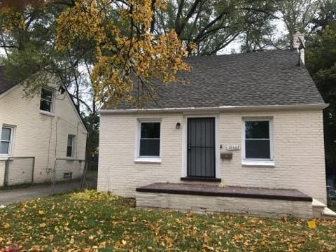 | FOR SALE  $68,600  MarketWise Property Group LLC  Joseph Reihl  682-593-6699

Exclusive Turnkey Rental Property For Sale
Rehabbed, Tenanted, And Property Managed

20162 Mitchell St, Detroit, Michigan 48234

Bedroom(s) | 3 | Description  BRICK 3 BEDROOM, 1 BATH HOUSE WITH NEW SECTION 8 TENANT  COMPLETELY REMODELED WITH NEW:  FURNACE, WATER HEATER, VINYL WINDOWS AND BLINDS, FULL KITCHEN, BATHROOM VANITY, MIRROR, NEW VINYL AND CARPET THROUGHOUT, ALL LIGHTING, PLUMBING AND PLUMBING FIXTURES, ELECTRICAL PANEL AND FIXTURES, FULL BASEMENT WITH GLASS BLOCK WINDOWS INSTALLED  ROOF WITH 30 YEAR ARCHITECTURAL SHINGLES (2-3 YEARS OLD)  EXCELLENT MANAGEMENT IN PLACE  MORE DETAILS: https://marketwise.cashflowready.com/Property/1808/7295
Bathroom(s) | 1
Square Feet | 1400
Year Built | 1943
Type | SFR
Lot Size | 4578
Rental Amount | $800
Tax per year | $1280

Call Laura -- 682-593-6699

